**Chapter 1: INTRODUCTION**

* 1. **Computer Graphics**

[Graphics](https://www.geeksforgeeks.org/introduction-to-computer-graphics/geeksforgeeks.org/computer-graphics-2/) are defined as any sketch or a drawing or a special network that pictorially represents some meaningful information. Computer Graphics is used where a set of images needs to be manipulated or the creation of the image in the form of pixels and is drawn on the computer. Computer Graphics can be used in digital photography, film, entertainment, electronic gadgets, and all other core technologies which are required. It is a vast subject and area in the field of computer science. Computer Graphics can be used in UI design, rendering, geometric objects, animation, and many more. In most areas, computer graphics is an abbreviation of CG. There are several tools used for the implementation of Computer Graphics. The basic is the <graphics.h> header file in Turbo-C, Unity for advanced and even OpenGL can be used for its Implementation. It was invented in 1960 by great researchers Verne Hudson and William Fetter from Boeing.

Computer Graphics refers to several things:

* The manipulation and the representation of the image or the data in a graphical manner.
* Various technology is required for the creation and manipulation.
* Digital synthesis and its manipulation.
  1. **Application**

1. **Computer Graphics are used for an** **aided design for engineering and architectural system-**  These are used in electrical automobiles, electro-mechanical, mechanical, electronic devices. For example: gears and bolts.
2. **Computer Art-**  MS Paint.
3. **Presentation Graphics-** It is used to summarize financial statistical scientific or economic data. For example: Bar chart, Line chart.
4. **Entertainment-** It is used in motion pictures, music videos, television gaming.
5. **Education and training-** It is used to understand the operations of complex systems. It is also used for specialized system such for framing for captains, pilots and so on.
6. **Visualization-** To study trends and patterns. For example: Analyzing satellite photo of earth.
   1. **Walking Stickman Carrying Balloons**

This project under Computer Graphics is an implementation of walking stickman carrying balloons game using the Turbo C++.

**1.3.1 Scope**

The program runs itself in the continuous loop until and unless the user presses any key from the keyboard. So, to terminate the program, the user must press any key from the keyboard.

**1.3.2 Objectives**

The objective of this program is to draw stickman carrying balloon and make them walk or move in horizontal direction. As soon as the stickman completes one lap over the screen it starts another lap. So, in this way, the man keeps walking or moving in a horizontal direction throughout the screen continuously. To stop the program, the user must press any key from the keyboard.

Keyboard function:

Press any key to terminate the program.

**Chapter 2: BASIC COMMANDS AND FUNCTIONS**

1. **initgraph()**

It is one of the functions in graphics.h that is used to initialize the computer in graphics mode.

Syntax: initgraph(&gdriver, &gmode,”graphics driver path”);

1. **closegraph()**

It is the graphical function that is used to close the graphics mode initialized by the initgraph() function.

Syntax: closegraph()

1. **setcolor()**

It is the function that is used to set the color of the drawing object with given color.The color is indicated by the integer from 0 to 15(16 color).

Syntax: setcolor(COLOR)

1. **line()**

It is a function to draw a line from current position to (x,y) position.

Syntax: line( int x1, int y1, int x2, int y2);

1. **circle()**

The header file graphics.h contains circle() function which draws a circle with centre at (x,y) and radius r.

Syntax: Circle(x, y, radius)

1. **ellipse()**

It is used to draw an ellipse with (x,y) coordinates of the centre of ellipse, stangle is the starting angle and end angle and X Y are the radius of ellipse

Syntax: ellipse(int x, int y, int stangle, int endangle, int x rad,int y rad);

1. **outtextxy()**

The header file graphics.h contains **outtext()** function which displays text or string at specified position (x,y) on screen.

Syntax: outtextxy(int x, int y, char*string)

1. **setbkcolor()**

It changes current background color.

Syntax: setbkcolor(COLOR)

1. **setfillstyle()**

This function sets current fill pattern and fill color.

Syntax: setfillstyle(int pattern, int color)

1. **floodfill()**

This function is used to fill an enclosed area.

Syntax: floodfill(int x, int y, int border_color)

1. **kbhit()**

It is function used to check whether key is pressed or not. kbhit(). To use 'kbhit' function you must include <conio.h> header file. If a key is pressed then it returns a non-zero value, otherwise returns zero.

**Chapter 3: REQUIREMENT ANALYSIS**

**3.1 Software Requirements**

Operating system like Windows XP, Windows 7, Window 8, Windows 10 and Windows 11 is the platform required to develop 2D graphics applications.

Turbo C++ compiler is required for compiling the source code to make the executable file which can then be directly executed.

**3.2 Hardware Requirements**

The hardware requirements are very minimal and the software can be made to run on most of the machines.

Processor: Above x86

Processor Speed: 500 MHz and above

RAM: 64 MB or above storage space 4 GB and more

Monitor Resolution: A color monitor with minimum resolution of 630*470

**Chapter 4: METHODOLOGY**

Following are the steps below to generate a walking stick man carrying balloons:

* Define the screen width, screen height and the level of the ground where we want to draw the road.
* Pass the three arguments to the [initgraph() function](https://www.geeksforgeeks.org/basic-graphic-programming-in-c/) to initialize the graphics driver and graphics mode.
* Create a road stretched from left to right at bottom part using line.
* Create the head and body of the stick man by drawing circle and lines respectively.
* The next step is to create the string to hold balloon by drawing lines and balloons by drawing ellipse.
* Choose the coordinates so that the stick man and the balloons are above the road.
* Change the value of leg and x-coordinates using a loop continuously (till we press key on the keyboard) so that man and the balloons appears to be moving on the road.
* Add the background color. Also, fill the colors or patterns in the balloons.

**Chapter 5: RESULT AND ANALYSIS**

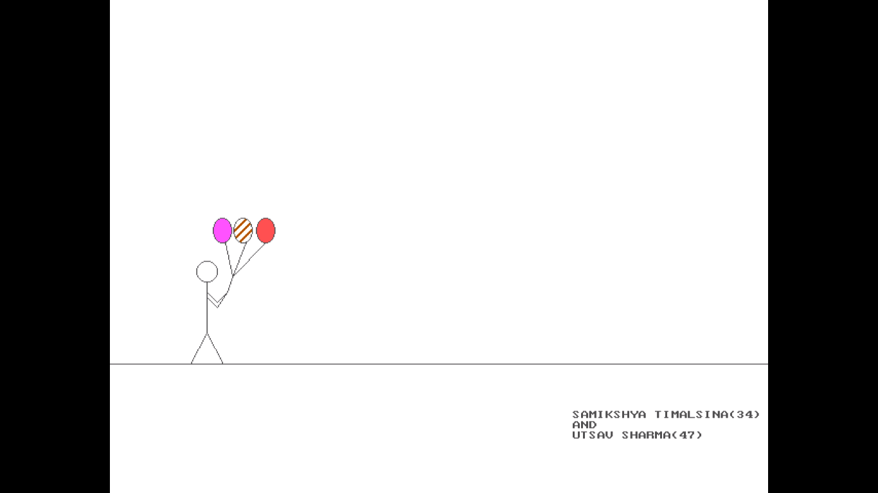

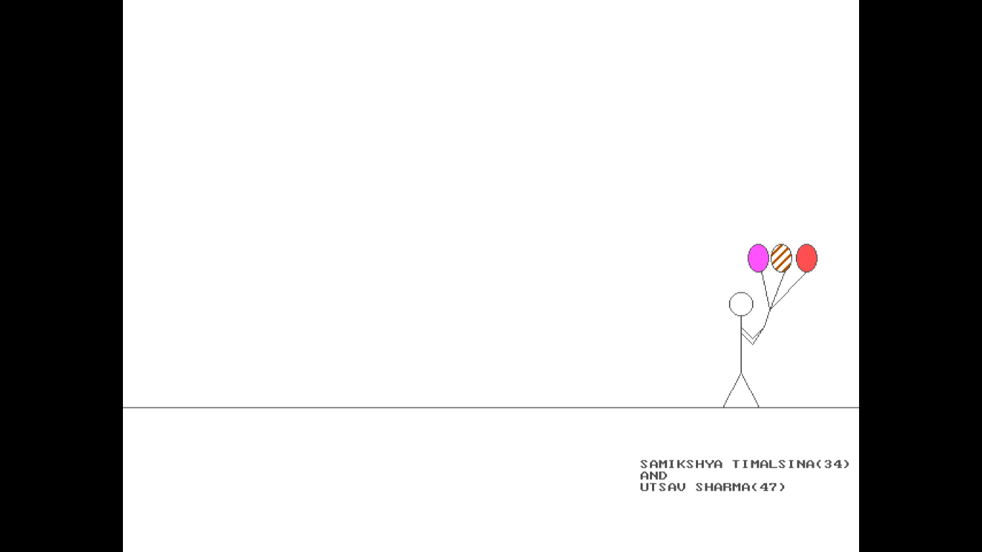

**Chapter 6: CONCLUSION AND FURTHER ENHANCEMENT**

Thus, the project has been completed successfully and it could have been further enhanced. This project is well suited for designing 2D object as well as carrying out basic functionalities like drawing a simple line, drawing ellipse and filling them. However, we were able to complete our project in time and hence by drawing the Stickman and Balloons using the feature of graphics in turbo C++, we completed our project.

In this program, we have used kbhit() for executing the continuous loop. So, until and unless the user presses a key the continuous loop won’t be terminated.

In future version, addition of some more in-built model of geometric figures, option to change line thickness, pickup color of line according to users’ requirement is a feasible idea.

**REFERENCES**

<https://github.com/CodAffection>

https://www.geeksforgeeks.org

https://stackoverflow.com

**APPENDICES**

**Appendix A: Source Code**

#include<conio.h>

#include<graphics.h>

#define sw getmaxx()

#define sh getmaxy()

#define gr sh*0.74

void manandballoon(int,int);

void main()

{

int gd=DETECT,gm,x=0,leg=0;

initgraph(&gd,&gm,"C:\\TurboC3\\BGI");

while(!kbhit())

{

setbkcolor(WHITE);

setcolor(DARKGRAY);

outtextxy(450,400,"SAMIKSHYA TIMALSINA(34)");

outtextxy(450,410,"AND");

outtextxy(450,420,"UTSAV SHARMA(47)");

line(0,gr,sw,gr);

leg=(leg+2)%20;

manandballoon(x,leg);

delay(70);

cleardevice();

x=(x+2)%sw;

}

getch();

closegraph();

}

void manandballoon(int x,int leg)

{

//head

circle(x,gr-90,10);

line(x,gr-80,x,gr-30);

//hand

line(x,gr-70,x+10,gr-60);

line(x,gr-65,x+10,gr-55);

line(x+10,gr-60,x+20,gr-70);

line(x+10,gr-55,x+20,gr-70);

//legs

line(x,gr-30,x+leg,gr);

line(x,gr-30,x-leg,gr);

//balloons

line(x+25,gr-85,x+20,gr-70);

setfillstyle(SOLID_FILL,LIGHTMAGENTA);

ellipse(x+15,gr-130,0,360,9,12);

floodfill(x+15,gr-130,DARKGRAY);

line(x+25,gr-85,x+18,gr-118);

setfillstyle(SLASH_FILL,BROWN);

ellipse(x+35,gr-130,0,360,9,12);

floodfill(x+35,gr-130,DARKGRAY);

line(x+25,gr-85,x+38,gr-118);

setfillstyle(SOLID_FILL, LIGHTRED);

ellipse(x+57,gr-130,0,360,9,12);

floodfill(x+57,gr-130,DARKGRAY);

line(x+25,gr-85,x+57,gr-118);

}